5. Get all employee details from the employee table order by First_Name Ascending and Salary descending?

ANS : 1) order by First_Name Ascending
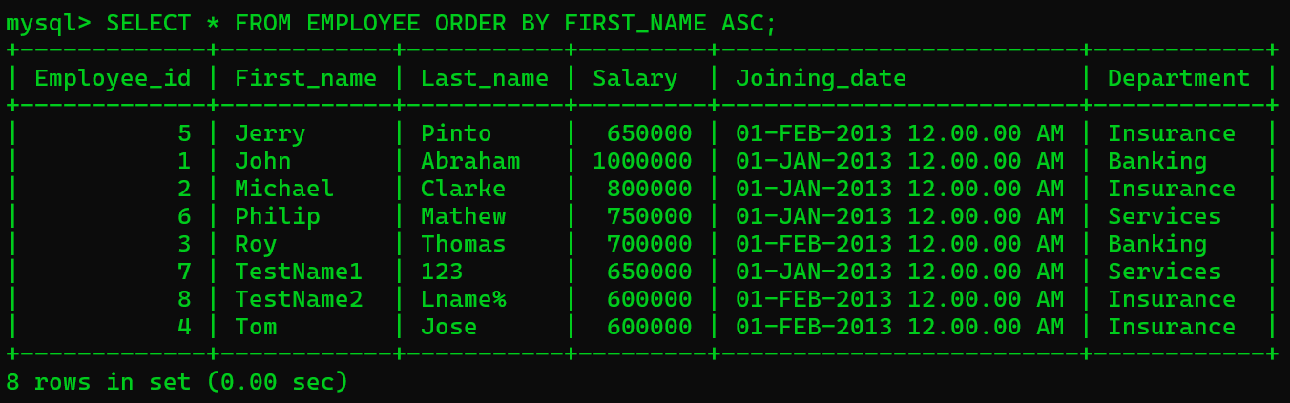

2) order by Salary Descending Order

